WATSON: The Final Problem

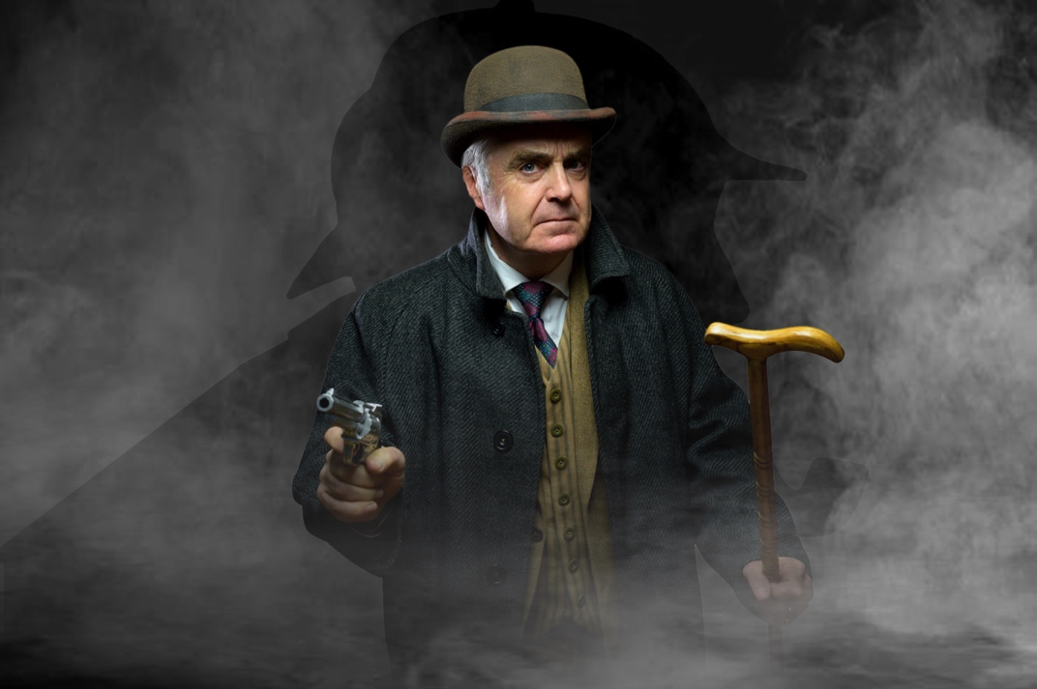

Trailer: https://youtu.be/RE-e4yywsqI
Full length audio version: https://youtu.be/QGEdTGG7caQ
​
In this internationally acclaimed, award winning 5* solo performance, Tim Marriott re-enacts a classic Sherlock Holmes adventure from the perspective of unsung hero, Dr John Watson.
SELL-OUT Show Edinburgh 21, 22, 23, and at Brits Off Broadway 24
“5* Utterly brilliant” - Edinburgh Review
"Superb, authentic, an excellent production" - Broadway World
“Highly recommended, Tim Marriott is tremendous in the title role" – Emporium
“A grippingly fine display - outstanding” - Broadway Baby
“Edinburgh Festival Fringe Favourite” – The Scotsman

Watson. An old soldier with a few bruises and a cracking story to tell.

1894. Watson is alone. His beloved wife Mary and the great Sherlock Holmes are both gone. But London seethes with false reports and rumour. It is time to set the record straight.
​
So Watson tells his tale... a tale of long buried secrets, betrayal and death. For there is a shadow in the gutters of London. A spider's web of poisonous intrigue lies across the city. Someone is playing a long game and Holmes and Watson face their greatest ever challenge. But as Watson unravels the threads of the story, a nagging doubt persists… is the game really over?
​
Watson is performed by Tim Marriott (BBC's The Brittas Empire) who was awarded Best Performance at Edinburgh Festival 2022 and Best Actor in 2023 and is co-written and directed by Bert Coules (BBC's The Further Adventures of Sherlock Holmes; Cadfael; Rebus).

Smokescreen Productions was founded by Tim Marriott in 2017, travelling to festivals around the world with acclaimed PTSD play Shell Shock (Best Solo Show, Adelaide) and Holocaust themed Mengele (Lustrum Award, Edinburgh, NY Encore). More recently Watson and corporate comedy Appraisal, were sell-out shows at Edinburgh and Adelaide 22 and 23, followed by two further sell-out seasons at Brits Off Broadway 24 and 25 in New York.

90s sitcom star Tim played Gavin in seven seasons of The Brittas Empire and British Airman, Tigger Thompson, in Allo, Allo, before moving into teaching in Eastbourne. He returned to the stage in 2018, committed to producing educational and thematic drama. Tim won Dark Chat Awards at Edinburgh Festival for Best Performance in 22 and Best Actor 23.

Smokescreen Productions is a not-for-profit company founded by Tim Marriott, returning to the stage after a long career break in education. The company was set up to produce issue based theatre. A 'Sell-Out' season at Edinburgh Festival in 2017 with Mengele and Shell Shock resulted in an invitation to Adelaide Fringe, where Mengele was once again a Sell-Out show, including four extra performances, and Shell Shock was awarded Best Solo Show (Sunday Mail). Further 'Sell-Out' festival seasons were achieved at Edinburgh 18, 19, 21, 22, 23, winning multiple 5* reviews, two Lustrum Awards, two Dark Chat Festival awards, as well as Watson being declared The Scotsman’s ‘Fringe Favourite’ and The List’s ‘Best of the Best’.
​
Mengele and Shell Shock proved to be successful touring productions in the UK, Australia and the US, and Watson has built on that growing reputation proving to have particularly broad audience appeal and remarkable box office potential.
​
WATSON COMPANY: 1 performer + 1 tech
RUNNING TIMES: One Act: 70 mins + post show Q&A as required
Two Act: 35mins/35mins

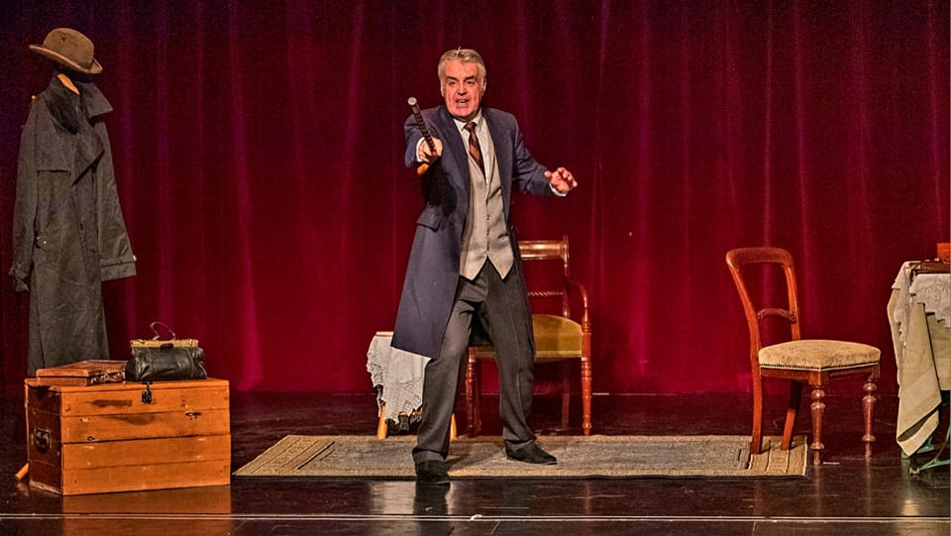

TECHNICAL INFORMATION

All our shows have grown out of the festival environment so are not difficult to stage. A minimum performance space of 4M x 3M, basic lighting and a sound system are all that is required. LX operation may require a resident technician as well as our own.
A: Centre Spot Special (Steel Blue Lee 117 or similar)
B: Warm Wash (mixed colour)
C: Near Vertical Special (Red 106 or similar)
Ideally, but not essential
F1: 1 Steel Blue Birdie or floor mounted minim (optional)
AV/FX Qlab/Keynote cues provided on external hard​ ​drive and/or Mac Laptop

Amplification and speakers with fold-back.
Script available on request or provided on the day - to be operated by in-house operator or travelling tech.
​
Stage
Our shows require only a bare, clean, open stage with clean black tabs with cyclorama or pale backdrop for projection.
Space Required Min 4m wide x 3m deep - Max 7m x 5m (lit space). Suitable for any auditoria, performances have ranged from intimate, fringe style studio theatres (50 seats) to large-scale outdoor auditoria seating up to 1000.
Clean black flooring, tabs & cyc or backdrop are required. If the floor is very scuffed, please repaint or lay dance floor.
​​
Set up & Rehearsal Approximately 3 hours depending on the size of the space
​
PAST SEASONS & AWARDS:
BRITS OFF BROADWAY: Sell-Out shows in 24 and 25 at 59E59 Theaters, NYC
Edinburgh Festival: Best performance 22, Best Actor 23
Australia Tours: 18, 23, 24.
Edinburgh Fringe: Sold-Out 17, 18, 19, 21, 22, 23 - Lustrum Awards 18 & 19
BEST OF THE BEST: The List, Adelaide 23
FRINGE FAVOURITE: The Scotsman 21
Fringe Encore: SoHo Playhouse NYC, 18
Adelaide Fringe 18, 19, 20, 23
Sunday Mail Award, Best Solo Show Shell Shock 18
Amnesty International Certificate of Achievement 18
INVICTUS GAMES Shell Shock tour of Australia Sept-Nov 18
​​​​
CONTACT:
Phone: 07773 777521 – Email: TM@smokescreenprods.com
Web: www.smokescreenprods.com
FB: @smokescreenEB
X: @guv47
You Tube Channel: @timmarriott5522

